ACKNOWLEDGEMENT

We want to express our sincere gratitude to our guide Ms. G. Chaitanya Bharathi, Assistant Professor, of Computer Science & Engineering, for his excellent guidance and invaluable support, which helped us to accomplish our Bachelor's degree and prepared us to achieve more life goals in the future. His total support of our dissertation and countless technical and professional development contributions made for a delightful and fruitful experience.

We are very much grateful to our Project Coordinator, Mr. Md. Irfan, Assistant Professor of CSE, GNITC, Hyderabad, who is not only shown utmost patience but was fertile in suggestions, vigilant in directions of error, and have been infinitely helpful.

We were also thankful to Dr. Geeta Tripathi, Professor & HOD-1 of CSE GNITC, Hyderabad, for being so helpful with valuable insights and guidance during our project.

We wish to express our sincere thanks to Dr. Rishi Sayal, Professor & Associate Director of CSE, GNITC for providing us with the conductive environment for carrying through our academic schedules and project with ease.

On a more personal note, we thank our beloved parents and friends for their moral support during our project.

J Manideep (21WJ1A05D1)
B Teja Reddy(22WJ5A0506)
G Madhuri(22WJ5A0509)

CAREFUL DDOS SECLUDING WITH QUICK LPM

ABSTRACT

Can software-based packet filters effectively dampen volumetric distributed denial-of-service (DDoS) streams in an era when 10 Gbps links are considered slow? The potential of longest prefix matching (LPM) for enforcing precise DDoS scrubbing policies seems to be overlooked in contemporary packet filtering data paths, and in this paper, we argue that this should not be the case by showing that effective whitelist / blacklist LPM-based filtering can be performed with commodity hardware. A showcase data path we propose can evaluate multiple queries in large separate LPM databases for each forwarded 64-byte packet, while sustaining 10 Gbps line rate on a single CPU core, with a healthy scaling potential due to its lockless architecture and small memory footprint of LPM structures. We demonstrated forwarding 64 million packets per second using only six CPU cores while performing independent lookups for each packet in three large LPM databases created by aggregating malicious IP addresses or by mapping different geolocation identifiers to IPv4 prefixes.

TABLE OF CONTENTS
CHAPTER NO. | TITLE | PAGE NO.
1. | CHAPTER 1 : INTRODUCTION  - GENERAL  - OBJECTIVE  - EXISTING SYSTEM  1.3.1 EXISTING SYSTEM DISADVANTAGES  1.3.2 LITERATURE SURVEY  1.4 PROPOSED SYSTEM  1.4.1 PROPOSED SYSTEM ADVANTAGES
2. | CHAPTER 2 : PROJECT DESCRIPTION  2.1 GENERAL  2.2 PROBLEM DEFINATION  2.3 METHODOLOGIES  2.3.1 MODULES NAME  2.3.2 MODULES EXPLANATION  2.3.3 MODULE DIAGRAM  2.3.4 GIVEN INPUTAND EXPECTED OUTPUT  2.4 TECHNIQUE OR ALGORITHM
3. | CHAPTER 3 : REQUIREMENTS  3.1 General  3.2 Hardware REQUIREMENTS  3.3 Software REQUIREMENTS  3.4 Functional Specification  3.5 Non-Functional SpecificatioN
4. | CHAPTER 4 : SYSTEM DESIGN  4.1 general  4.2 Uml  4.2.1 USE CASE diagram  4.2.2 CLASS DIAGRAM  4.2.3 OBJECT DIAGRAM  4.2.4 COMPONENT DIAGRAM  4.2.5 DEPLOYMENT DIAGRAM  4.2.6 SEQUENCED DIAGRAM  4.2.7 COLLABARATION DIAGRAM  4.2.8 STATE DIAGRAM  4.2.9 ACTIVITY DIAGRAM  4.3 DATA FLOW DIAGRAM  4..4 ER DIAGRAM  4.5 SYSTEM ARCHETECTURE
5. | CHAPTER 5 :SOFTWARE SPECIFICATION  5.1 general FRONT END  5.2 features of java  5.2.1 the java framework  5.2.2 objective of java  5.2.3 componets of java frmework  5.2.4 Evolution of collection framework  5.3 features of the common language runtime  5.4 j2ee  5.4.1 EVALUTION OF J2EE  5.4.2 THE J2EE DATA ARCHITECTURE  5.5.3 COMPONENT CLASSES THAT MAKE UP  DATA PROVIDERS
6. | CHAPTER 6 : IMPLEMENTATION  6.1 GENERAL  6.2 IMPLEMENTATION  6.3 DATA BASE TABLE STRUCTURE
7. | CHAPTER 7 : SNAPSHOTS  7.1 GENERAL  7.2 VARIOUS SNAPSHOTS
8. | CHAPTER 8 : SOFTWARE TESTING  8.1 GENERAL  8.2 DEVELOPING METHODOLOGIES  8.3 TYPES OF TESTING
9. | CHAPTER 9 :  9.1 CONCLUSION  9.2 REFERENCES

LIST OF FIGURES
FIGURE NO | NAME OF THE FIGURE | PAGE NO.
2.3.2 | Module Diagram
4.2.1 | Use case Diagram
4.2.2 | Class Diagram
4.2.3 | Object Diagram
4.2.4 | Component Diagram
4.2.5 | Deployment Diagram
4.2.6 | Sequence Diagram
4.2.7 | Collaboration Diagram
4.2.8 | State Diagram
4.2.9 | Activity Diagram
4.3 | Data Flow Diagram
4.4 | E-R Diagram
4.5 | System Architecture
7.1 | Home Page

LIST OF SYSMBOLS

S.NO | NAME | NOTATION |  | DESCRIPTION
1. | Class | Class Name  -attribute  -attribute  +operation  +operation  +operation  + public  -private  # protected |  | Represents a collection of similar entities grouped together.
2. | Association | name  Class B  Class A  Class A  Class B |  | Associations represents static relationships between classes. Roles represents the way the two classes see each other.
3. | Actor | Class A  Class A  Class B  Class B |  | It aggregates several classes into a single classes.
5. | Aggregation |  |  | Interaction between the system and external environment
5. | Relation  (uses) |  | Uses |  | Used for additional process communication.
6. | Relation  (extends) |  | extends |  | Extends relationship is used when one use case is similar to another use case but does a bit more.
7. | Communication |  |  |  | Communication between various use cases.
8. | State |  | State |  | State of the process.
9. | Initial State |  |  |  | Initial state of the object
10. | Final state |  |  |  | Final state of the object
11. | Control flow |  |  |  | Represents various control flow between the states.
12. | Decision box |  |  |  | Represents decision making process from a constraint
13. | Usecase |  | Uses case |  | Interact ion between the system and external environment.
14. | Component |  | Represents physical modules which is a collection of components.
15. | Node |  | Represents physical modules which are a collection of components.
16. | Data Process/State |  | A circle in DFD represents a state or process which has been triggered due to some event or action.
17. | External entity |  | Represents external entities such as keyboard,sensors,etc.
18. | Transition |  | Represents communication that occurs between processes.
19. | Object Lifeline |  | Represents the vertical dimensions that the object communications.
20. | Message | Message | Represents the message exchanged.

LIST OF ABBREVATION
S.NO | ABBREVATION | EXPANSION
1. | DB | DataBase
2. | JVM | Java Virtual Machine
3. | JSP | Java Server Page
4. | PWS | Personalised Web Search
5. | UPS | User Personalised Search
6. | JRE | Java Runtime Environment

CHAPTER 1
INTRODUCTION
  - GENERAL

The proliferation of still predominantly IPv4-based volumetric/flooding distributed denial-of-service (DDoS) attacks, which are exploiting the openness and simplicity of the Internet’s addressing and routing architecture, is placing an increasing burden on Internet service providers (ISP) and data center operators. An effective mitigation strategy has to include scrubbing malicious from legitimate traffic close to the attack target. Packet filtering using specialized hardware such as ternary content addressable memories (TCAMs) offers high throughput, but TCAMs have a rigid structure, low density, suffer from high power consumption, and are costly. In a quest for more flexibility and virtualization capabilities, a new interest in implementing high-speed packet filters in software has recently emerged. Legacy software firewalls available in general-purpose operating systems (OS) were designed when speeds of 100 Mbps and 1 Gbps were considered fast, but in today’s data centers, even 10 Gbps network interface cards (NICs) are gradually being replaced by 25, 40, or 100 Gbps parts. Moreover, software data paths have evolved towards generalizations such as OpenFlow, which aim to adapt to all conceivable packet manipulation scenarios, with emphasis on stateful operation. However, the precise flow tracking caching paradigm suffers from a wide spectrum of inherent architectural limitations. Particularly in the context of volumetric DDoS attacks, as source addresses of inbound packets are either randomized (spoofed), or the packets originate from vast pools of compromised or vulnerable hosts, the elastically expanding flow tracking structures either quickly reach their preset limits, or spill over CPU’s caches. Furthermore, synchronizing access to mutable shared data structures such as flow tables can require tens to hundreds of CPU clock cycles per table access, itself consuming the entire per-packet time budget for a single 10 Gbps link. The need for simplifying and stripping down packet processing software data paths of non-essential functions is well recognized and can be reflected in the widespread adoption of fast packet I/O frameworks such as DPDK or Net map, which map NIC buffers directly into user space. More recently proposed mechanisms for fast (pre)processing of packets before they get encapsulated and consumed by complex data structures and function call paths in an OS kernel are currently enjoying gigantic momentum: eBPF/XDP, are re-exploring the paradigm of safe just in-time (JIT) translation of packet filtering programs from bytecode form to native machine code within a running Linux kernel, refining it to adapt more efficiently to modern CPU architectures, and making it more versatile. A surprising common denominator among software data path proposals from the recent literature (user space and XDP based alike) is that only a few have explored the advances in longest prefix matching (LPM) reported over the past decade. Most user space proposals use the popular DIR-24- 8 scheme available as a library in DPDK, while XDP relies on the even older LC-trie, and rare exceptions such as the Kamuee router, which uses Pop Trie for LPM, do not focus on packet filtering. Therefore, in this paper, we explore whether there are incentives for moving away from the omnipresent DIR-24-8 to more modern LPM schemes in DDoS filtering scenarios, which call for methods to blacklist 105 to 106 individual compromised host addresses, such as in the well-exposed Mirai DDoS incidents from 2016.

1.2 OBJECTIVE
The objective of this some works focus on verifying the correctness of ranked search results by foreseeing the ranked results. A single keyword ranked veriﬁcation scheme based on the hash chain. It present a veriﬁable dynamic searching scheme leveraging the RSA accumulator to build a veriﬁable matrix for veriﬁable updates and searches, which fails to support multi keyword searching.
1.3 SCOPE OF THE PROJECT
Veriﬁable Searching over Encrypted Data. Veriﬁable searching over encrypted data requires the searchable encryption schemes to verify the correctness of search results. Some works only verify whether all of the encrypted documents containing the single query word returned by the cloud.
1.4 EXISTING SYSTEM:
- Most of the existing secure semantic searching schemes consider the semantic relationship among words to perform query expansion on the plaintext, then still use the query words and extended semantically related words to perform exact matching with the speciﬁc keywords in outsourced documents
- In existing semantic searching schemes, the veriﬁable searching does not be supported since it is dependent on the forecasted results from predeﬁned keywords to verify the search results from cloud, and the queries are expanded on plaintext and the exact matching is performed by the extended semantically words with predeﬁned keywords, which limits their accuracy.
1.4.1 Existing System Disadvantages:
- It does not have security of the data user and data owner.
- While the file is uploading we can’t have a security.
1.5 LITERATURE SURVEY
TITLE: Survey of blockchain innovation weaknesses and blockchain-framework assaults.
AUTHOR: A. Averin and O. Averina.
YEAR: 2021.
DESCRIPTION:
Blockchain is a generally youthful innovation. As of late, blockchain has acquired prevalence, which continues to develop. Such interest is mostly because of digital currencies, like Bitcoin and Ethereum. This innovation has introduced promising possibilities of use. With the rising interest in blockchain from digital currency to savvy contracts, there are points of reference of assaults on the blockchain stage. This, thusly, energizes thought of blockchain concerning security, distinguishing weaknesses and anticipating the development of new weaknesses. That further would permit to track down new strategies and answers for blockchain security. In this paper, the realized weaknesses were thought of, as well as the known assaults on blockchain and their effective executions lately.
TITLE: From foundations to code: Towards computerized age of savvy contracts.
AUTHOR: C. K. Frantz and M. Nowostawski.
YEAR: 2022.
DESCRIPTION:
Blockchain innovation has arisen as an answer for consistency issues in shared networks. At this point, it has developed as an answer for a scope of purpose cases in which it can successfully give the idea of outsider trust without the requirement for a trusted (physical) outsider, which makes it an alluring coordination component for disseminated frameworks. To advance the wide reception of this innovation, we yet need instruments that make the detail and translation of savvy contracts open to a more extensive crowd. In this work, we propose a demonstrating approach that upholds the semi-robotized interpretation of comprehensible agreement portrayals into computational reciprocals to empower the codification of regulations into certain and enforceable computational designs that live inside a public blockchain. We distinguish brilliant agreement parts that relate to genuine establishments, and propose a planning that we operationalize involving a space explicit language to help the agreement demonstrating process. We investigate this capacity in light of chosen models and plot out bearings for future exploration on brilliant agreements.
TITLE: system for digital currencies which utilizes blockchain innovation to give an open worldwide registering stage.
AUTHOR: I. Goienetxea, J. M. Mart´ınez-Otzeta, B. Sierra, and I. Mendialdua
YEAR: 2021.
DESCRIPTION:
Ethereum is a system for digital currencies which utilizes blockchain innovation to give an open worldwide registering stage, called the Ethereum Virtual Machine (EVM). EVM executes bytecode on a straightforward stack machine. Software engineers don't as a rule compose EVM code; all things considered, they can program in a JavaScript-like language, called Strength that gathers to bytecode. Since the principal reason for EVM is to execute savvy gets that oversee and move advanced resources (called Ether), security is of central significance. Nonetheless, composing secure shrewd agreements can be very troublesome: because of the receptiveness of Ethereum, the two projects and pseudonymous clients can call into the public techniques for different projects, prompting possibly risky creations of trusted and untrusted code. This hazard was as of late represented by an assault on TheDAO contract that took advantage of unpretentious subtleties of the EVM semantics to move generally $50M worth of Ether into the control of an aggressor. In this paper, we frame a structure to break down and check both the runtime security and the utilitarian rightness of Ethereum shrinks by interpretation to F*, a practical programming language focused on program confirmation.
TITLE: An experimental investigation of savvy contracts: Stages, applications, and configuration designs.
AUTHOR: M. Bartoletti and L. Pompianu.
YEAR: 2020.
DESCRIPTION:
Brilliant agreements are PC programs that can be reliably executed by an organization of commonly doubting hubs, without the mediation of a confided in power. In view of their versatility to altering, savvy contracts are engaging in numerous situations, particularly in those which require moves of cash to regard specific concurred rules (like in monetary administrations and in games). Throughout recent years numerous stages for savvy contracts have been proposed, and some of them have been really executed and utilized. We concentrate on how the idea of shrewd agreement is deciphered in a portion of these stages. Zeroing in on the two most boundless ones, Bitcoin and Ethereum, we evaluate the utilization of brilliant agreements corresponding to their application space. We additionally examine the most widely recognized programming designs in Ethereum, where the source code of shrewd agreements is accessible.
TITLE: Smart contracts: Terminology, technical limitations and real world complexity.
AUTHOR: S. K. Kermanshahi, J. K. Liu, R. Steinfeld, and S. Nepal
YEAR: 2022 .
DESCRIPTION:
If one is to believe the popular press and many “technical writings,” blockchains create not only a perfect transactional environment but also obviate the need for banks, lawyers and courts. The latter will soon be replaced by smart contracts: unbiased and infallible computer programs that form, perform and enforce agreements. Predictions of future revolutions must, however, be distinguished from the harsh reality of the commercial marketplace and the technical limitations of blockchain technologies. The fact that a technological solution is innovative and elegant need not imply that it is commercially useful or legally viable. Apart from attempting a terminological “clean-up” surrounding the term smart contract, this paper presents some technological and legal constraints on their use. It confronts the commonly made claims concerning their ability to automate the transacting process and to ensure perfect performance. It also examines the possibility of reducing contractual relationships into code and the ability to integrate smart contracts with the complexities of the real world. A closer analysis reveals that smart contracts can hardly be regarded as a semi-mythical technology liberating the contracting parties from the shackles of traditional legal and financial institutions. While some of their technical features seem prima facie attractive, especially to non-lawyers, a closer analysis reveals their many shortcomings.
1.6 PROPOSED SYSTEM
- In this paper, we propose a secure veriﬁable semantic.
- Searching scheme that treats matching between queries and documents as an optimal matching task. We treat the document words as “suppliers,” the query words as “consumers,” and the semantic information as “product,” and design the minimum word transportation cost (MWTC) as the similarity metric between queries and documents.
1.6.1 PROPOSED SYSTEM ADVANTAGE
- Providing more security
- Reducing storage cost.
- For secure semantic optimal matching on the cipher text,

CHAPTER 2
PROJECT DESCRIPTION
2.1 GENERAL:
We assume that the data owner is trusted, and the data users are authorized by the data owner. The communication channels between the owner and users are secure on existing security protocols such as SSL, TLS. With regard to the cloud server, our scheme resists a more challenging security model which is beyond the “semi-honest server” used in other secure semantic searching schemes. In our model, the dishonest cloud server attempts to return wrong/forged search results and learn sensitive information, but would not maliciously delete or tamper with the outsourced documents. Therefore, our secure semantic scheme should guarantee the veriﬁability, and conﬁdentiality under such a security model.
2.2 METHODOLOGIES
2.2.1MODULES NAME:
1. User
2. Admin
3. DDos Detection

1. User
In this module we design the windows for the project. These windows are used for secure login for all users. To connect with server user must give their username and password then only they can able to connect the server. If the user already exits directly can login into the server else user must register their details such as username, password and Email id, into the server. Server will create the account for the entire user to maintain upload and download rate. Name will be set as user id. Logging in is usually used to enter a specific page.

User Login

Server
Upload File
Home Page
Register &Login Page

2. Admin
This is the first module Data User can register and Login. After login Data User have an option of searching the files as a file name. Data user can also have a download file it will show an encrypted data. Data user can also send a trapdoor request to the server. Server can accept the request and then data user can takes permissions from the owner then the file it will downloaded in plain text.
View Files
View Users
Admin
Login

Data Base
Register

3. DDos Detection
DDoS traffic, the task of a filtering data path is to move packets from one interface to another after classifying them and applying appropriate actions as quickly as possible, while still providing elementary operating statistics. Secondary functions may also include diverting manageable amounts of samples to a separate packet processor for detailed analysis. An external tool, such as a DDoS detection system, may use the collected sampled packets and traffic statistics to generate filtering rulesets in the event of an attack,

External network

DDos Detection
Administration

Protected network

2.3 GIVEN INPUT EXPECTED OUTPUT:

- User
Input : Enter Login name and Password
Output : If valid user name and password then directly open the home page otherwise show error message and redirect to the registration page.
- Admin
Input : Data User Login name and Password
Output: If valid user name and password then directly open the Data user home page
otherwise show error message and redirect to the data user login page.
- DDos Detection
Input : Enter the owner name and password
Output : If valid owner name and password then directly open the data owner home page
otherwise show error message and redirect to the data owner login page.

2.4 TECHNIQUE USED OR ALGORITHM USED
2.4.1 PROPOSED ALGORITHM
LPM SCHEME
We argue and show that the use of LPM offers significant potential for the development of new DDoS scrubbing strategies. Our research indicates that using large datasets as allowlists and blocklists (usually called whitelists and blacklists) allows for precise, high-speed filtering of IPv4 traffic. To support our case, we refine a modern LPM lookup scheme and integrate it into a packet filtering application that allows multiple independent LPM queries to be performed per packet using randomized keys (IP addresses) while maintaining a 10 Gbps line rate on a single CPU core. We defy the currently prevailing view which favors placing high-speed packet filtering functions as JIT-compiled modules in an OS kernel by demonstrating that efficient user space filtering data paths can be constructed with fewer constraints. Finally, our results are practical: the prototype described here includes all the components necessary for a real-world application: a comprehensive filter description language matched with a fast parser and compiler front-end, as well as a functional control interface with on-the-fly reconfiguration and statistics gathering capabilities. LPM stands for Longest Prefix Match, a routing technique used in networking to determine the best route for data packets based on the longest matching prefix in the routing table.
Significance of LPM in DDoS Mitigation
LPM can enhance DDoS scrubbing strategies by improving the efficiency of traffic filtering and routing. It allows for more precise identification of malicious traffic patterns, enabling quicker responses to potential DDoS attacks. Potential Benefits of LPM in DDoS Scrubbing

Enhanced Traffic Filtering
LPM can help in identifying and filtering out malicious traffic more effectively by matching incoming traffic against known attack patterns.
This results in reduced false positives and ensures legitimate traffic is not blocked.

Dynamic Routing Adjustments
With LPM, routers can dynamically adjust their routing tables to prioritize legitimate traffic and reroute suspicious traffic to scrubbing centers.
This adaptability is crucial during an ongoing DDoS attack, allowing for real-time mitigation.
Scalability
LPM can handle large volumes of traffic, making it suitable for high-capacity networks that are often targets of DDoS attacks.
As network demands grow, LPM can scale to accommodate increased traffic without compromising performance.

2.4.2 EXISTING SYSTEM
- KNN ALGORITHM
Definition: The k-Nearest Neighbors (kNN) algorithm is a supervised machine learning method used for classification and regression tasks. It operates on the principle of similarity, predicting the label or value of a new data point based on the labels or values of its k nearest neighbors in the training dataset.
Selecting the Optimal Value of k:
The value of k represents the number of nearest neighbors to consider when making predictions.
Choosing an appropriate k is crucial; a smaller k can be sensitive to noise, while a larger k can smooth out the decision boundary.
Calculating
Distance: The algorithm typically uses distance metrics like Euclidean distance to measure similarity between data points. The distance between a new data point ( x ) and each point ( Xi) in the training set is calculated.
Finding Nearest Neighbors:
The k data points with the smallest distances to the target point are identified as the nearest
neighbors.
Voting for Classification or Averaging for Regression:
Classification: The predicted class is determined by majority voting among the k nearest neighbors.
CHAPTER 3
REQUIREMENTS ENGINEERING
3.1 GENERAL
We have conducted experiments on our collected dataset and extensive results have demonstrated that our model outperforms all other existing models. In the future, we will investigate more tasks under this framework, such as event summarization and event attribute mining in social media.

3.2 HARDWARE REQUIREMENTS
The hardware requirements may serve as the basis for a contract for the implementation of the system and should therefore be a complete and consistent specification of the whole system. They are used by software engineers as the starting point for the system design. The hardware requirements should specify what the system should do, rather than how it should be implemented.
- PROCESSOR : DUAL CORE 2 DUOS.
- RAM : 2GB DD RAM
- HARD DISK : 250 GB

3.3 SOFTWARE REQUIREMENTS
The software requirements document is the specification of the system. It should include both a definition and a specification of requirements. It is a set of what the system should do rather than how it should do it. The software requirements provide a basis for creating the software requirements specification. It is useful in estimating cost, planning team activities, performing tasks and tracking the teams and tracking the team’s progress throughout the development activity.

SOFTWARE REQUIREMENTS
- FRONT END : J2EE (JSP, SERVLET)
- BACK END : MY SQL 5.5
- OPERATING SYSTEM : WINDOWS 7
- IDE : ECLIPSE

3.4 FUNCTIONAL REQUIREMENTS
User Login:
The system shall allow registered users to log in using their username and password.
The system shall validate user credentials and provide access to the user dashboard upon successful login. The system shall provide an error message for invalid login attempts.
File Search:
The system shall allow users to search for files by file name.
The system shall return a list of files that match the search criteria, including metadata (e.g., file size, upload date).
File Download:
The system shall allow users to download files, which will be presented in an encrypted format.
The system shall provide a mechanism to decrypt the file after the user has obtained the necessary permissions.
Trapdoor Request Module
The system shall allow users to send a trapdoor request to the server for specific files.
Traffic Filtering:
The system shall classify incoming packets based on predefined criteria to identify potential DDoS traffic.
The system shall apply appropriate actions to classified packets (e.g., allow, block, rate-limit).
The system shall maintain elementary operating statistics (e.g., number of packets processed, number of packets filtered).
3.5 NON-FUNCTIONAL REQUIREMENTS
EFFICIENCY
Our multi-modal event tracking and evolution frameworks suitable for multimedia documents from various social media platforms, which can not only effectively capture their multi-modal topics, but also obtain the evolutionary trends of social events and generate effective event summary details over time. Our proposed mm ETM model can exploit the multi-modal property of social event, which can effectively model social media documents including long text with related images and learn the correlations between textual and visual modalities to separate the visual-representative topics and on-visual-representative topics.

CHAPTER 4
DESIGN ENGINEERING
4.1 GENERAL
Design Engineering deals with the various UML [Unified Modelling language] diagrams for the implementation of project. Design is a meaningful engineering representation of a thing that is to be built. Software design is a process through which the requirements are translated into representation of the software. Design is the place where quality is rendered in software engineering. Design is the means to accurately translate customer requirements into finished product.
4.2 UML DIAGRAMS
4.2.1 USE CASE DIAGRAM

EXPLANATION:
A use case diagram represent users or other systems that interact with your system. These can be primary (directly using the system) or secondary (supporting the primary actor). Describe the functional requirements of the system. Each use case represents a goal that an actor wants to achieve. A rectangle that defines the scope of the system. Use cases are inside the rectangle, while actors are outside.
Association: Lines connecting actors to use cases, showing interactions.
Include: A relationship where a use case includes the functionality of another use case.
Extend: A relationship where a use case can be extended by another use case, typically used for optional
This image is a use case diagram that shows the interactions between actors and the system.
Admin can view users and files.
User can upload files.
DDoS Detection interacts with the external network, administration, and the protected network.
The diagram helps to understand the functional requirements of the system. It shows what actions can be performed by each actor. It also helps to understand how the different parts of the system .
4.2.2 CLASS DIAGRAM

EXPLANATION
A class diagram is a type of static structure diagram that shows the system's classes, their attributes, methods, and the relationships among the classes.
Classes: Represented as rectangles divided into three sections:
Top section: Class name.
Middle section: Attributes (properties/fields).
Bottom section: Methods (functions/operations).
Attributes: Variables that hold data for the class, usually with visibility indicators (e.g., + for public, - for private).
Methods: Functions that define the behaviour of the class, also with visibility indicators.
Relationships
Association: A line connecting two classes, indicating a relationship.
Inheritance: A solid line with a closed arrowhead pointing to the parent class.
Aggregation: A hollow diamond at the parent side of the line.
Composition: A filled diamond at the parent side of the line, indicating a strong relationship.
Dependency: A dashed line indicating that one class depends on another.
4.2.3 OBJECT DIAGRAM

EXPLANATION:
An object diagram is a type of static structure diagram in UML (Unified Modelling Language) that shows a snapshot of the instances of classes (objects) at a specific moment in time. It represents the objects and their relationships, giving a more detailed view than class diagrams by showing actual instances.

Key Components of Object Diagrams:
- Objects: Represented as rectangles with the object name followed by a colon and the class name (e.g., customer1: Customer).
- Attributes: The specific state of an object is shown by its attributes, which can be listed inside the rectangle (e.g., name: John Doe, email: johndoe@example.com).
- Links: Lines connecting objects to represent their relationships (similar to associations in class diagrams). The lines can also have labels to indicate the nature of the relationship.
The diagram shows the relationships between three actors: User, DDoS Detection, and Admin. The User interacts with the DDoS Detection. The DDoS Detection also interacts with the Admin. The User and the Admin interact with each other. This suggests that there is a system to detect and prevent DDoS attacks. The User may be the source of the attack, or may be the target of the attack. The DDoS Detection system is responsible for identifying and blocking the attack. The Admin can manage and configure the system. The Admin may need to be alerted to any attacks, and may be able to take action to mitigate the attack.
4.2.4 COMPONENT DIAGRAM

EXPLANATION

A component diagram is a type of structural diagram in UML (Unified Modelling Language) that illustrates how software components interact within a system. It shows the organization and dependencies among various components, making it easier to understand the system architecture.

Key Components of a Component Diagram:
- Components: Represented as rectangles with two smaller rectangles on the top. Each component encapsulates functionality and is defined by its interfaces.
- Interfaces: Provided and required interfaces are shown as circles (lollipops) for provided
- Interfaces and half circles (sockets) for required interfaces.
- Dependencies: Dashed arrows indicate dependencies between components, showing how components rely on one another.
- Packages: Sometimes used to group components and manage complex diagrams.
4.2.5 DEPLOYMENT DIAGRAM
EXPLANATION:
A deployment diagram is a type of structural diagram in UML (Unified Modelling Language) that illustrates the physical deployment of artifacts on nodes. It shows how software components are deployed across hardware components and how they interact with each other in a system architecture.

Key Components of a Deployment Diagram:
- Nodes: Represent physical or virtual machines (servers, devices) where software components are deployed. They can be depicted as 3D cubes.
- Artifacts: Represent the physical files or executables (like .jar files, .war files) deployed on nodes. Artifacts are usually shown as rectangles.
- Relationships:
  - Communication Paths: Lines connecting nodes to represent network connections.
  - Dependency: Dashed arrows indicating that one artifact or component depends on another.
4.2.6 SEQUENCE DIAGRAM
EXPLANATION:
A sequence diagram is a type of interaction diagram in UML (Unified Modeling Language) that shows how objects interact in a particular scenario of a use case, emphasizing the order of messages exchanged between them. It provides a detailed view of the flow of control and data in a system.

Key Components of a Sequence Diagram:
- Lifelines: Vertical dashed lines representing objects or participants in the interaction. Each lifeline is labelled with the object name and, optionally, the class name.

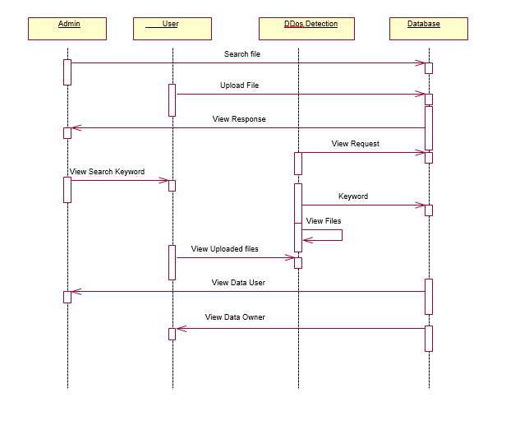
- Activation Boxes: Rectangles on a lifeline indicating the period during which an object is active or controlling the flow of the interaction.
- Messages: Horizontal arrows between lifelines indicating communication. Messages can be:
  - Synchronous (solid line arrow): The caller waits for a response.
  - Asynchronous (open arrowhead): The caller does not wait for a response.
  - Return messages (dashed arrow): Indicate a response or return value.
- Conditions and Loops: Notations for showing conditions (if statements) or loops (repeating processes) in the flow.

4.2.7 COLLABORATION DIAGRAM

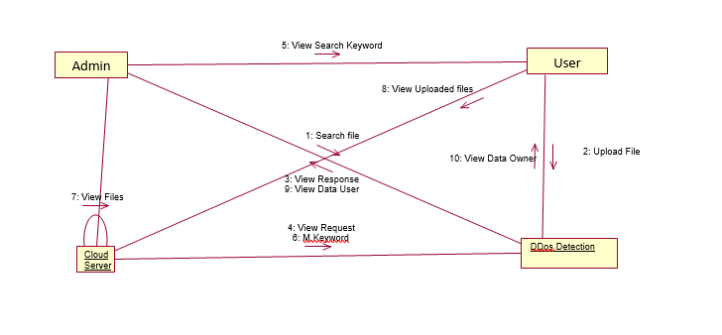
EXPLANATION:
A collaboration diagram, also known as a communication diagram, is a type of interaction diagram in UML (Unified Modelling Language) that emphasizes the relationships between objects and the messages they exchange to accomplish a specific task. It focuses on how objects collaborate to perform a specific function or use case, showing the structural organization of the objects involved.
Key Components of a Collaboration Diagram:
- Objects: Represented as boxes, each labelled with the object name (and optionally the class name).
- Links: Lines connecting objects, indicating relationships between them.
- Messages: Arrows along the links indicating the messages exchanged. Each message is numbered to indicate the sequence of interactions, and they can include details about the message being sent.
The diagram shows the interactions between data users, data owners, and a cloud server for searching and retrieving data. Here's a breakdown of the steps
Data User Searches: A data user initiates a search for a specific file.
Data Owner Uploads: A data owner uploads files to the database.
Cloud Server Processes: The cloud server receives the search request and processes it against the database.
4.2.8 STATE DIAGRAM
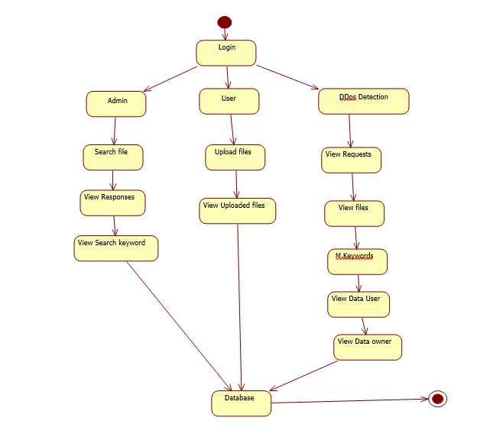

EXPLANATION:
A state diagram, also known as a state machine diagram, is a type of behavioral diagram in UML (Unified Modelling Language) that describes the states of an object and how it transitions between those states in response to events. It is particularly useful for modelling the lifecycle of an object and understanding how it behaves in different situations.

Key Components of a State Diagram:
- States: Represented as rounded rectangles, states describe the various conditions or situations in which an object can exist. The initial state is shown as a filled circle, while the final state is represented by a circle surrounding a smaller filled circle.
- Transitions: Arrows connecting states indicate the movement from one state to another. Each transition is typically labelled with the event that triggers it and may include conditions (guards) that must be met for the transition to occur.
- Events: Triggers that cause a transition to occur. These can be user actions, system events, or conditions being met.
- Actions: Activities that occur during transitions or while in a particular state. These can be entry actions, exit actions, or activities that occur while in a state.
4.2.9 ACTIVITY DIAGRAM
EXPLANATION:
An activity diagram is a type of behavioral diagram in UML (Unified Modelling Language) that illustrates the dynamic aspects of a system by modelling the flow of control or data within a process. It represents the sequence of activities, actions, and decisions in a system, similar to a flowchart, and is particularly useful for detailing business processes or workflows.

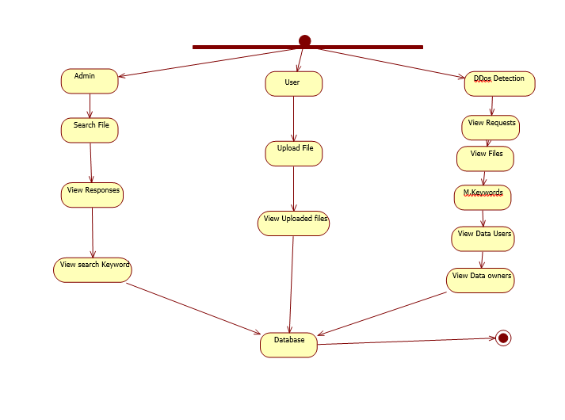

Key Components of an Activity Diagram:
- Activities: Represented as rounded rectangles, these are the tasks or actions performed in the process.
- Transitions: Arrows that connect activities, showing the flow from one activity to another.
- Decision Nodes: Diamond shapes that represent points where a decision is made, leading to different paths in the flow based on conditions.
- Start and End Nodes: A filled circle indicates the starting point, while a circle with a surrounding border represents the end of the process.
- Forks and Joins: Used to represent parallel processes. A fork splits a flow into multiple parallel flows, while a join merges them back into a single flow.
- Swim lanes: Horizontal or vertical divisions that organize activities by the responsible actor (e.g., user, system) or department
The flow chart shows the following steps:
4.3 DATA FLOW DIAGRAM
Level 0
Register
Home Page
Login
Verify Details
Data base
Error page

Level 1
Keys
Attacker details
Data user request
Search Files
Login
Admin
DDos Detection
Data base
Upload Files
User
Requested Files
Login
Data user Information
Files
Data owner information
Login

EXPLANATION:
A data flow diagram (DFD) is a graphical representation of the "flow" of data through an information system, modelling its process aspects. Often they are a preliminary step used to create an overview of the system which can later be elaborated. DFDs can also be used for the visualization of data processing (structured design).
In this module, we focus on designing a secure login system for users to access a server. The process begins with user authentication, where individuals must provide their username and password to connect to the server. If a user is new, they must register by submitting their username, password, and email address, allowing the server to create an account for them. The username will serve as the user ID, and logging in will grant access to specific functionalities.
Once logged in, users can search for files by name and download them, although the data will initially be encrypted. Users also have the option to send a trapdoor request to the server, which, upon approval from the file owner, allows them to download the file in plain text.
Additionally, the module addresses the challenge of DDoS (Distributed Denial of Service) attacks. It outlines the need for a filtering data path that efficiently moves packets between interfaces while classifying them and applying necessary actions. This system will also collect basic operating statistics and may divert a manageable number of packets for detailed analysis by an external DDoS detection tool. This tool can utilize the sampled packets and traffic statistics to create filtering rules in the event of an attack, ensuring the server remains secure and operational.

4.4 E-R DIAGRAM

Attacker Details
Send Keys
Search file
Login
Name
Data base
Request Send
Requested Files
Upload Files
Login
Data User Info
Stored Files
Data owner Information
Login
User

Password
Name
User

Password
Name
DDos Detection

Password
Verify
Details

EXPLANATION:
Entity-Relationship Model (ERM)
User Authentication
User Login: A user provides their name and password to access the system.
Verification: The system verifies the user's credentials against the database.
Search File: Users can search for specific files.
Requested Files: The system records the files the user requests.
Upload Files: Users can upload files to the system.
4.5 SYSTEM ARCHITECTURE
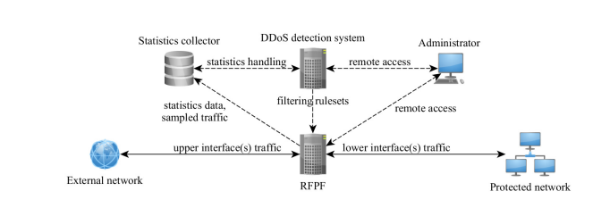
EXPLANATION
In this project data owner has a register all details and then login. the module addresses the challenge of DDoS (Distributed Denial of Service) attacks. It outlines the need for a filtering data path that efficiently moves packets between interfaces while classifying them and applying necessary actions.
CHAPTER 5
DEVELOPMENT TOOLS
  - GENERAL
This chapter is about the software language and the tools used in the development of the project. The platform used here is JAVA. The Primary languages are JAVA, J2EE and J2ME. In this project J2EE is chosen for implementation.
5.2 FEATURES OF JAVA
5.2.1 THE JAVA FRAMEWORK
Java is a programming language originally developed by James Gosling at Microsystems and released in 1995 as a core component of Sun Microsystems' Java platform. The language derives much of its syntax from C and C++ but has a simpler object model and fewer low-level facilities. Java applications are typically compiled to byte code that can run on any Java Virtual Machine (JVM) regardless of computer architecture. Java is general-purpose, concurrent, class-based, and object-oriented, and is specifically designed to have as few implementation dependencies as possible. It is intended to let application developers "write once, run anywhere".
Java is considered by many as one of the most influential programming languages of the 20th century, and is widely used from application software to web applications the java framework is a new platform independent that simplifies application development internet. Java technology's versatility, efficiency, platform portability, and security make it the ideal technology for network computing. From laptops to data centers, game consoles to scientific supercomputers, cell phones to the Internet, Java is everywhere!

5.2.2 OBJECTIVES OF JAVA
To see places of Java in Action in our daily life, explore java.com.

WHY SOFTWARE DEVELOPERS CHOOSE JAVA
Java has been tested, refined, extended, and proven by a dedicated community. And numbering more than 6.5 million developers, it's the largest and most active on the planet. With its versatility, efficiency, and portability, Java has become invaluable to developers by enabling them to:
- Write software on one platform and run it on virtually any other platform
- Create programs to run within a Web browser and Web services
- Develop server-side applications for online forums, stores, polls, HTML forms processing, and more
- Combine applications or services using the Java language to create highly customized applications or services
- Write powerful and efficient applications for mobile phones, remote processors, low-cost consumer products, and practically any other device with a digital heartbeat

SOME WAYS SOFTWARE DEVELOPERS LEARN JAVA
Today, many colleges and universities offer courses in programming for the Java platform. In addition, developers can also enhance their Java programming skills by reading Sun's java.sun.com Web site, subscribing to Java technology-focused newsletters, using the Java Tutorial and the New to Java Programming Center, and signing up for Web, virtual, or instructor-led courses.
OBJECTORIENTED
To be an Object Oriented language, any language must follow at least the four characteristics.
1. Inheritance : It is the process of creating the new classes and using the behavior of the existing classes by extending them just to reuse the existing code and adding addition a features as needed.
2. Encapsulation: It is the mechanism of combining the information and providing the abstraction.
3. Polymorphism: As the name suggest one name multiple form, Polymorphism is the way of providing the different functionality by the functions having the same name based on the signatures of the methods.
4. Dynamic binding: Sometimes we don't have the knowledge of objects about their specific types while writing our code. It is the way of providing the maximum functionality to a program about the specific type at runtime.
5.2.3 JAVA SWING OVERVIEW
ABSTRACT WINDOW TOOLKIT (AWT) IS CROSS-PLATFORM
Swing provides many controls and widgets to build user interfaces with. Swing class names typically begin with a J such as JButton, JList, JFrame. This is mainly to differentiate them from their AWT counterparts and in general is one-to-one replacements. Swing is built on the concept of Lightweight components vs AWT and SWT's concept of Heavyweight components. The difference between the two is that the Lightweight components are rendered (drawn) using purely Java code, such as drawLine and draw Image, whereas Heavyweight components use the native operating system to render the components. Some components in Swing are actually heavyweight components. The top-level classes and any derived from them are heavyweight as they extend the AWT versions. This is needed because at the root of the UI, the parent windows need to be provided by the OS. These top-level classes include JWindow, JFrame, JDialog and JApplet. All Swing components to be rendered to the screen must be able to trace their way to a root window of one of those classes.
NOTE: It generally it is not a good idea to mix heavyweight components with lightweight components (other than as previously mentioned) as you will encounter layering issues, e.g., a lightweight component that should appear "on top" ends up being obscured by a heavyweight component.

5.2.4 EVOLUTION OF COLLECTION FRAMEWORK:
Almost all collections in Java are derived from the java.util.Collection interface. Collection defines the basic parts of all collections. The interface states the add () and remove () methods for adding to and removing from a collection respectively. Also required is the to Array () method, which converts the collection into a simple array of all the elements in the collection. Finally, contains () method checks if a specified element is in the collection. The Collection interface is a sub interface of java.util.Iterable, so the iterator () method is also provided. All collections have an iterator that goes through all of the elements in the collection. Additionally, Collection is a generic. Any collection can be written to store any class. For example, Collection<String> can hold strings, and the elements from the collection can be used as strings without any casting required.
There are three main types of collections:
- Lists: always ordered, may contain duplicates and can be handled the same way as usual arrays
- Sets: cannot contain duplicates and provide random access to their elements
- Maps: connect unique keys with values, provide random access to its keys and may host duplicate values
LIST
Lists are implemented in the JCF via the java.util.List interface. It defines a list as essentially a more flexible version of an array. Elements have a specific order, and duplicate elements are allowed. Elements can be placed in a specific position. They can also be searched for within the list. Two concrete classes implement List. The first is java.util.ArrayList, which implements the list as an array. Whenever functions specific to a list are required, the class moves the elements around within the array in order to do it. The other implementation is java.util.LinkedList. This class stores the elements in nodes that each have a pointer to the previous and next nodes in the list. The list can be traversed by following the pointers, and elements can be added or removed simply by changing the pointers around to place the node in its proper place.
SET:
Java's java.util.Set interface defines the set. A set can't have any duplicate elements in it. Additionally, the set has no set order. As such, elements can't be found by index. Set is implemented by java.util.HashSet, java.util.LinkedHashSet, and java.util.TreeSet. HashSet uses a hash table. More specifically, it uses a java.util.HashMap to store the hashes and elements and to prevent duplicates. Java.util.LinkedHashSet extends this by creating a doubly linked list that links all of the elements by their insertion order. This ensures that the iteration order over the set is predictable. java.util.TreeSet uses a red-black tree implemented by a java.util.TreeMap. The red-black tree makes sure that there are no duplicates. Additionally, it allows Tree Set to implement java.util.SortedSet.
The java.util.Set interface is extended by the java.util.SortedSet interface. Unlike a regular set, the elements in a sorted set are sorted, either by the element's compare to () method, or a method provided to the constructor of the sorted set. The first and last elements of the sorted set can be retrieved, and subsets can be created via minimum and maximum values, as well as beginning or ending at the beginning or ending of the sorted set. The Sorted Set interface is implemented by java.util.TreeSet
Java.util.SortedSet is extended further via the java.util.NavigableSet interface. It's similar to Sorted Set, but there are a few additional methods. The floor (), ceiling (), lower (), and higher () methods find an element in the set that's close to the parameter. Additionally, a descending iterator over the items in the set is provided. As with Sorted Set, java.util.TreeSet implements Navigable Set.
MAP:
Maps are defined by the java.util.Map interface in Java. Maps are simple data structures that associate a key with a value. The element is the value. This lets the map be very flexible. If the key is the hash code of the element, the map is essentially a set. If it's just an increasing number, it becomes a list. Maps are implemented by java.util.HashMap, java.util.LinkedHashMap, and java.util.TreeMap. Hash Map uses a hash table. The hashes of the keys are used to find the values in various buckets. LinkedHashMap extends this by creating a doubly linked list between the elements. This allows the elements to be accessed in the order in which they were inserted into the map. TreeMap, in contrast to HashMap and LinkedHashMap, uses a red-black tree. The keys are used as the values for the nodes in the tree, and the nodes point to the values in the map
THREAD:
Simply put, a thread is a program's path of execution. Most programs written today run as a single thread, causing problems when multiple events or actions need to occur at the same time. Let's say, for example, a program is not capable of drawing pictures while reading keystrokes. The program must give its full attention to the keyboard input lacking the ability to handle more than one event at a time. The ideal solution to this problem is the seamless execution of two or more sections of a program at the same time.

CREATING THREADS
Java's creators have graciously designed two ways of creating threads: implementing an interface and extending a class. Extending a class is the way Java inherits methods and variables from a parent class. In this case, one can only extend or inherit from a single parent class. This limitation within Java can be overcome by implementing interfaces, which is the most common way to create threads. (Note that the act of inheriting merely allows the class to be run as a thread. It is up to the class to start () execution, etc.)
Interfaces provide a way for programmers to lay the groundwork of a class. They are used to design the requirements for a set of classes to implement. The interface sets everything up, and the class or classes that implement the interface do all the work.
5.5 CONCLUSION
Swing's high level of flexibility is reflected in its inherent ability to override the native host operating system (OS)'s GUI controls for displaying itself. Swing "paints" its controls using the Java 2D APIs, rather than calling a native user interface toolkit. The Java thread scheduler is very simple. All threads have a priority value which can be changed dynamically by calls to the threads set Priority () method.
CHAPTER 6
IMPLEMENTATION
6.1 GENERAL
CODING:
package com.controller;
import java.io.IOException;
import java.sql.SQLException;
import javax.servlet.ServletException;
import javax.servlet.annotation.WebServlet;
import javax.servlet.http.HttpServlet;
import javax.servlet.http.HttpServletRequest;
import javax.servlet.http.HttpServletResponse;
import javax.servlet.http.HttpSession;
import com.exceptions.MyExcetpion;
import com.model.RegisterModel;
import com.service.LoginService;

@WebServlet("/login")
public class LoginController extends HttpServlet {

/**
*
*/
private static final long serialVersionUID = 1L;

@Override
protected void doPost(HttpServletRequest req, HttpServletResponse resp) throws ServletException, IOException {

String emailid=req.getParameter("emailid");
String password=req.getParameter("password");

if(emailid.equalsIgnoreCase("admin@gmail.com") && password.equalsIgnoreCase("admin")) {

req.setAttribute("admin", "admin");
req.getRequestDispatcher("adminhome.jsp").forward(req, resp);

}else {

LoginService lc=new LoginService();
int userStatus=lc.userLogin(emailid, password);

if(userStatus==1 || userStatus==2) {
try {
RegisterModel rm=lc.getUserDetails(emailid);
HttpSession session = req.getSession();
session.setAttribute("account", rm);
String s= userStatus==2?"sql":"nosql";
if (s.equalsIgnoreCase("sql")) {
req.setAttribute("sql", "SQL INJECTION ATTACK");}

req.setAttribute("account", rm);
req.getRequestDispatcher("index.jsp").forward(req, resp);
} catch (ClassNotFoundException | SQLException | MyExcetpion e) {
e.printStackTrace();
}

}else {
String alert = "<div class=\"alert alert-danger wrap-input100\">\n" +
" <p style=\"font-family: Ubuntu-Bold; font-size: 18px; margin: 0.25em 0; text-align: center\">\n" +
" email/passowrd wrong!\n" +
" </p>\n" +
" </div>";
req.setAttribute("alert", alert);
req.getRequestDispatcher("login.jsp").forward(req, resp);
}
}
}

}
<!DOCTYPE html>
<html lang="en">

<head>
<meta charset="utf-8">
<meta content="width=device-width, initial-scale=1.0" name="viewport">

<title>VTJBC04</title>
<meta content="" name="description">
<meta content="" name="keywords">

<!-- Favicons -->
<link href="assets/img/favicon.png" rel="icon">
<link href="assets/img/apple-touch-icon.png" rel="apple-touch-icon">

<!-- Google Fonts -->
<link href="https://fonts.googleapis.com/css?family=Open+Sans:300,300i,400,400i,600,600i,700,700i|Jost:300,300i,400,400i,500,500i,600,600i,700,700i|Poppins:300,300i,400,400i,500,500i,600,600i,700,700i" rel="stylesheet">

<!-- Vendor CSS Files -->
<link href="assets/vendor/aos/aos.css" rel="stylesheet">
<link href="assets/vendor/bootstrap/css/bootstrap.min.css" rel="stylesheet">
<link href="assets/vendor/bootstrap-icons/bootstrap-icons.css" rel="stylesheet">
<link href="assets/vendor/boxicons/css/boxicons.min.css" rel="stylesheet">
<link href="assets/vendor/glightbox/css/glightbox.min.css" rel="stylesheet">
<link href="assets/vendor/remixicon/remixicon.css" rel="stylesheet">
<link href="assets/vendor/swiper/swiper-bundle.min.css" rel="stylesheet">

<!-- Template Main CSS File -->
<link href="assets/css/style.css" rel="stylesheet">

<!-- =======================================================
* Template Name: Arsha - v4.9.1
* Template URL: https://bootstrapmade.com/arsha-free-bootstrap-html-template-corporate/
* Author: BootstrapMade.com
* License: https://bootstrapmade.com/license/
======================================================== -->
</head>
<body>
<!-- ======= Header ======= -->
<header id="header" class="fixed-top ">
<div class="container d-flex align-items-center">
<br> <br> <br> <h2 class="logo me-auto"><a href="index.html">Blockchain Project</a></h2>
<!-- Uncomment below if you prefer to use an image logo -->
<!-- <a href="index.html" class="logo me-auto"><img src="assets/img/logo.png" alt="" class="img-fluid"></a>-->
<nav id="navbar" class="navbar">
<ul>
</ul>
<i class="bi bi-list mobile-nav-toggle"></i>
</nav><!-- .navbar -->
</div>
</header><!-- End Header -->
<!-- ======= Hero Section ======= -->
<section id="hero" class="d-flex align-items-center">

<div class="container">
<div class="row">
<div class="col-lg-6 d-flex flex-column justify-content-center pt-4 pt-lg-0 order-2 order-lg-1" data-aos="fade-up" data-aos-delay="200">
</div>
</div>
</section><!-- End Hero -->
<main id="main">
<div id="preloader"></div>
<a href="#" class="back-to-top d-flex align-items-center justify-content-center"><i class="bi bi-arrow-up-short"></i></a>

<!-- Vendor JS Files -->
<script src="assets/vendor/aos/aos.js"></script>
<script src="assets/vendor/bootstrap/js/bootstrap.bundle.min.js"></script>
<script src="assets/vendor/glightbox/js/glightbox.min.js"></script>
<script src="assets/vendor/isotope-layout/isotope.pkgd.min.js"></script>
<script src="assets/vendor/swiper/swiper-bundle.min.js"></script>
<script src="assets/vendor/waypoints/noframework.waypoints.js"></script>
<script src="assets/vendor/php-email-form/validate.js"></script>

<!-- Template Main JS File -->
<script src="assets/js/main.js"></script>
</body>
</html>
package com.controller;
import java.io.BufferedInputStream;
import java.io.ByteArrayInputStream;
import java.io.ByteArrayOutputStream;
import java.io.IOException;
import java.io.InputStream;
import java.io.PrintWriter;
import java.sql.SQLException;
import java.util.Scanner;
import javax.servlet.ServletException;
import javax.servlet.annotation.MultipartConfig;
import javax.servlet.annotation.WebServlet;
import javax.servlet.http.HttpServlet;
import javax.servlet.http.HttpServletRequest;
import javax.servlet.http.HttpServletResponse;
import javax.servlet.http.HttpSession;
import javax.servlet.http.Part;
import org.apache.commons.io.IOUtils;
import com.configurations.AppConfig;
import com.model.KycModel;
import com.model.RegisterModel;
import com.service.UploadKycService;
import com.utils.DbScanDuplicate;
import com.utils.HashCodeGenearate;
@WebServlet("/fileupload")
@MultipartConfig
public class UploadKycController extends HttpServlet {
private static final long serialVersionUID = 1L;
UploadKycService uks = new UploadKycService();
@Override
protected void doPost(HttpServletRequest req, HttpServletResponse resp) throws ServletException, IOException {

String fname = req.getParameter("fileName");
String userId=req.getParameter("userId");
Part part = req.getPart("file");
InputStream inputStream = part.getInputStream();

ByteArrayOutputStream baos = new ByteArrayOutputStream();
IOUtils.copy(inputStream, baos);
inputStream.close();
inputStream= new ByteArrayInputStream(baos.toByteArray());

Scanner s = new Scanner(inputStream).useDelimiter("\\A"); String result = s.hasNext() ? s.next() : "";
System.out.println("the content in file"+result);
inputStream.mark(10000);
inputStream.reset();

InputStream inputStream1 = new ByteArrayInputStream(baos.toByteArray());
Scanner s1 = new Scanner(inputStream1).useDelimiter("\\A");
String result1 = s1.hasNext() ? s1.next() : "";
System.out.println("the content in file"+result1);
int i=DbScanDuplicate.calculateDuplicate(result1);
if(i==1) {
System.out.println("The file is half percent same saving the file in popular data");
}else if(i==100) {
System.out.println("These file is the duplicate file it contains 100% popular data");
}else {
String path= this.getClass().getResource("/").getFile();
System.out.println("the file path is"+path);
KycModel kycModel = AppConfig.getKycmodel();
HttpSession session = req.getSession();
RegisterModel rm = (RegisterModel) session.getAttribute("account");
String genearatehash = fname.substring(0, 2);
String hashValue = HashCodeGenearate.getHashValue(genearatehash);
kycModel.setInputStream(new ByteArrayInputStream(baos.toByteArray()));
kycModel.setHashValue(hashValue);
kycModel.setUserid(rm.getUserid());
kycModel.setName(fname);
try {
boolean b = uks.uploadKyc(kycModel);
if(b==true) {
String info = "<div class=\"alert alert-success wrap-input100\">\n" +
" <p style=\"font-family: Ubuntu-Bold; font-size: 18px; margin: 0.25em 0; text-align: center\">\n" +
" Upload Success!\n" +
" </p>\n" +
" </div>";
req.setAttribute("info", info);
req.getRequestDispatcher("uploadkyc.jsp").forward(req, resp);
}else {
String alert = "<div class=\"alert alert-danger wrap-input100\">\n" +
" <p style=\"font-family: Ubuntu-Bold; font-size: 18px; margin: 0.25em 0; text-align: center\">\n" +
" KYC document updation failed\n" +
" </p>\n" +
" </div>";
req.setAttribute("alert", alert);
req.getRequestDispatcher("uploadkyc.jsp").forward(req, resp);

}
} catch (Exception e) {
e.printStackTrace();
String alert = "<div class=\"alert alert-danger wrap-input100\">\n" +
" <p style=\"font-family: Ubuntu-Bold; font-size: 18px; margin: 0.25em 0; text-align: center\">\n" +
" Image size is greater than 1mb \n" +
" </p>\n" +
" </div>";
req.setAttribute("alert", alert);
req.getRequestDispatcher("upload.jsp").forward(req, resp);
}

}
}

}
package com.controller;
import java.io.File;
import java.io.IOException;
import java.io.InputStream;
import java.nio.file.Files;
import java.nio.file.Paths;
import java.sql.SQLException;
import java.util.ArrayList;
import java.util.Arrays;
import java.util.List;
import java.util.Scanner;
import java.util.stream.Collectors;
import java.util.stream.Stream;
import javax.servlet.ServletException;
import javax.servlet.annotation.WebServlet;
import javax.servlet.http.HttpServlet;
import javax.servlet.http.HttpServletRequest;
import javax.servlet.http.HttpServletResponse;
import com.configurations.AppConfig;
import com.model.FileModel;
import com.service.UploadKycService;

/**
* Servlet implementation class ScanServlet
*/
@WebServlet("/ScanServlet")
public class ScanServlet extends HttpServlet {
private static final long serialVersionUID = 1L;

/**
* @see HttpServlet#HttpServlet()
*/
public ScanServlet() {
super();
// TODO Auto-generated constructor stub
}

/**
* @see HttpServlet#doGet(HttpServletRequest request, HttpServletResponse response)
*/
protected void doGet(HttpServletRequest request, HttpServletResponse response) throws ServletException, IOException {
// TODO Auto-generated method stub
response.getWriter().append("Served at: ").append(request.getContextPath());
}

/**
* @see HttpServlet#doPost(HttpServletRequest request, HttpServletResponse response)
*/
protected void doPost(HttpServletRequest request, HttpServletResponse response) throws ServletException, IOException {

UploadKycService uks=AppConfig.getuploadKycService();

try {
List<FileModel> files=uks.getFiles();
List<String> att1=new ArrayList<>();
Stream<String> attack = null;

for(FileModel file:files) {

File file1 = new File("D:\\major 2022\\BC04\\WebContent\\files\\encrypt\\"+file.getFileName()+".txt");
Scanner sc = new Scanner(file1);

while (sc.hasNextLine()) {
System.out.println(sc.nextLine());
if(sc.nextLine().contains("SQL")) {
att1.add(file.getFileName());
}
}

// attack=Files.lines(Paths.get("D:\\major 2022\\BC04\\WebContent\\files\\encrypt\\"+file.getFileName()+".txt"));
// attack.close();

//attack.close();
}
/*
* att1= attack.filter(x -> x.contains("SQL"))
*
* .collect(Collectors.toList());
*
* attack.close();*/

for(String s: att1) { System.out.println(s); }

String info = "<div class=\"alert alert-success wrap-input100\">\n" +
" <p style=\"font-family: Ubuntu-Bold; font-size: 18px; margin: 0.25em 0; text-align: center\">\n" +
" This files are suspicious\n" +
" </p>\n" +

" </div>";
request.setAttribute("info", info);
request.setAttribute("files", att1);
request.getRequestDispatcher("adminhome.jsp?userpage=scan").forward(request, response);
} catch (ClassNotFoundException e) {
e.printStackTrace();
} catch (SQLException e) {
// TODO Auto-generated catch block
e.printStackTrace();
}
}
}

CHAPTER 7
SNAPSHOTS
7.1 GENERAL:
This project is implements like web application using COREJAVA and the Server process is maintained using the SOCKET & SERVERSOCKET and the Design part is played by Cascading Style Sheet.
7.2 SNAPSHOTS
Fig 7.2.1 Register Page
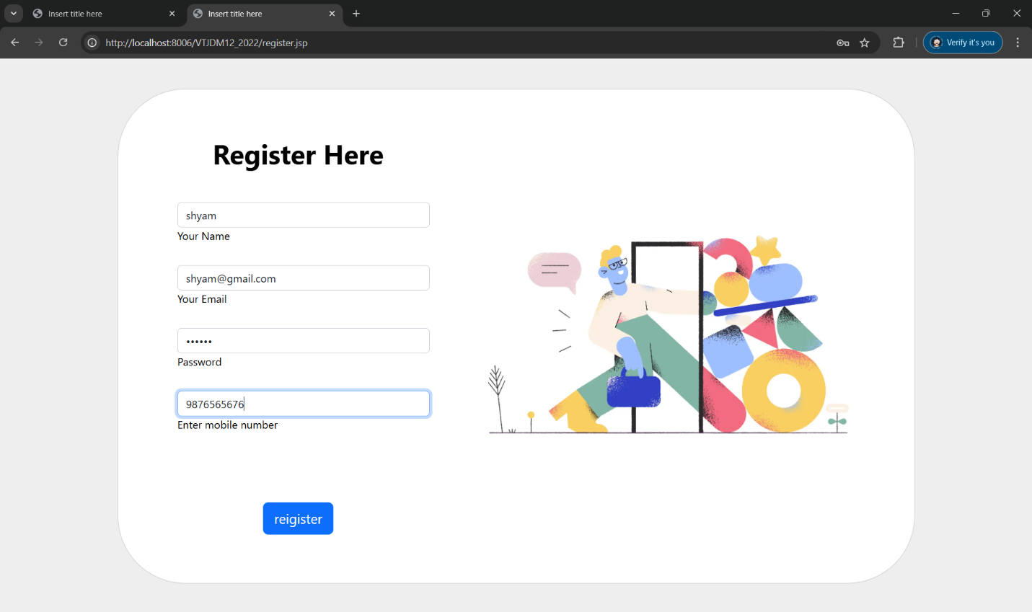

Fig 7.2.2 Login
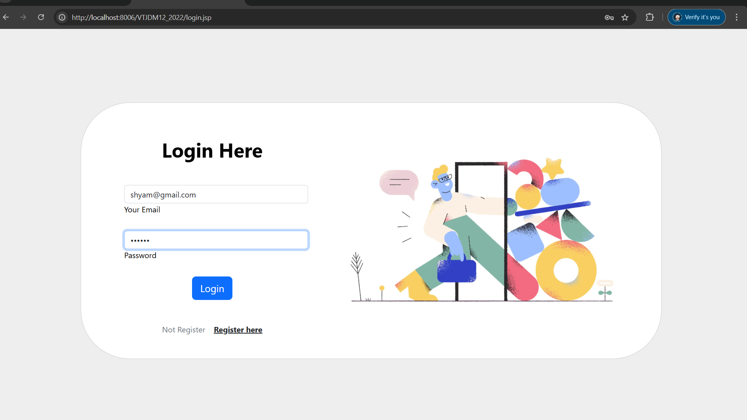
Fig 7.2.3 Profile
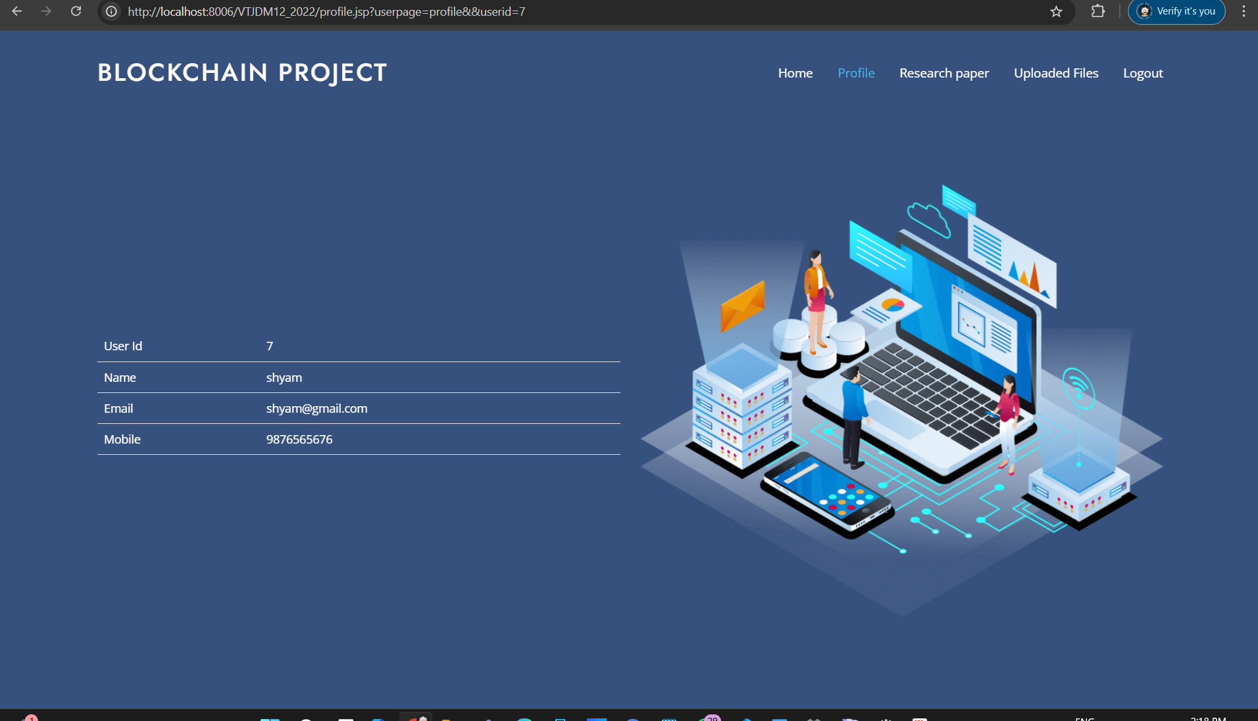

Fig 7.2.4 User Contracts
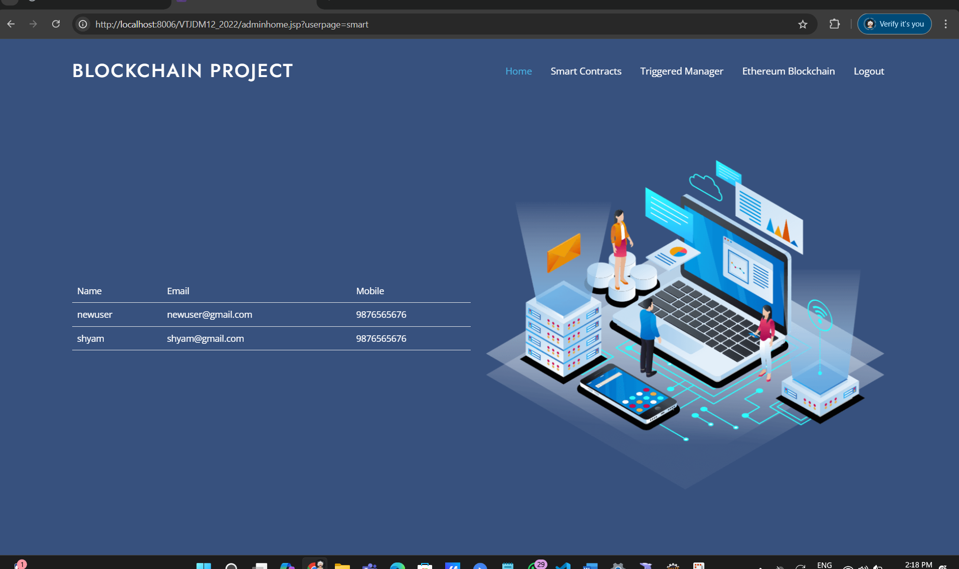
Fig 7.2.5 Security
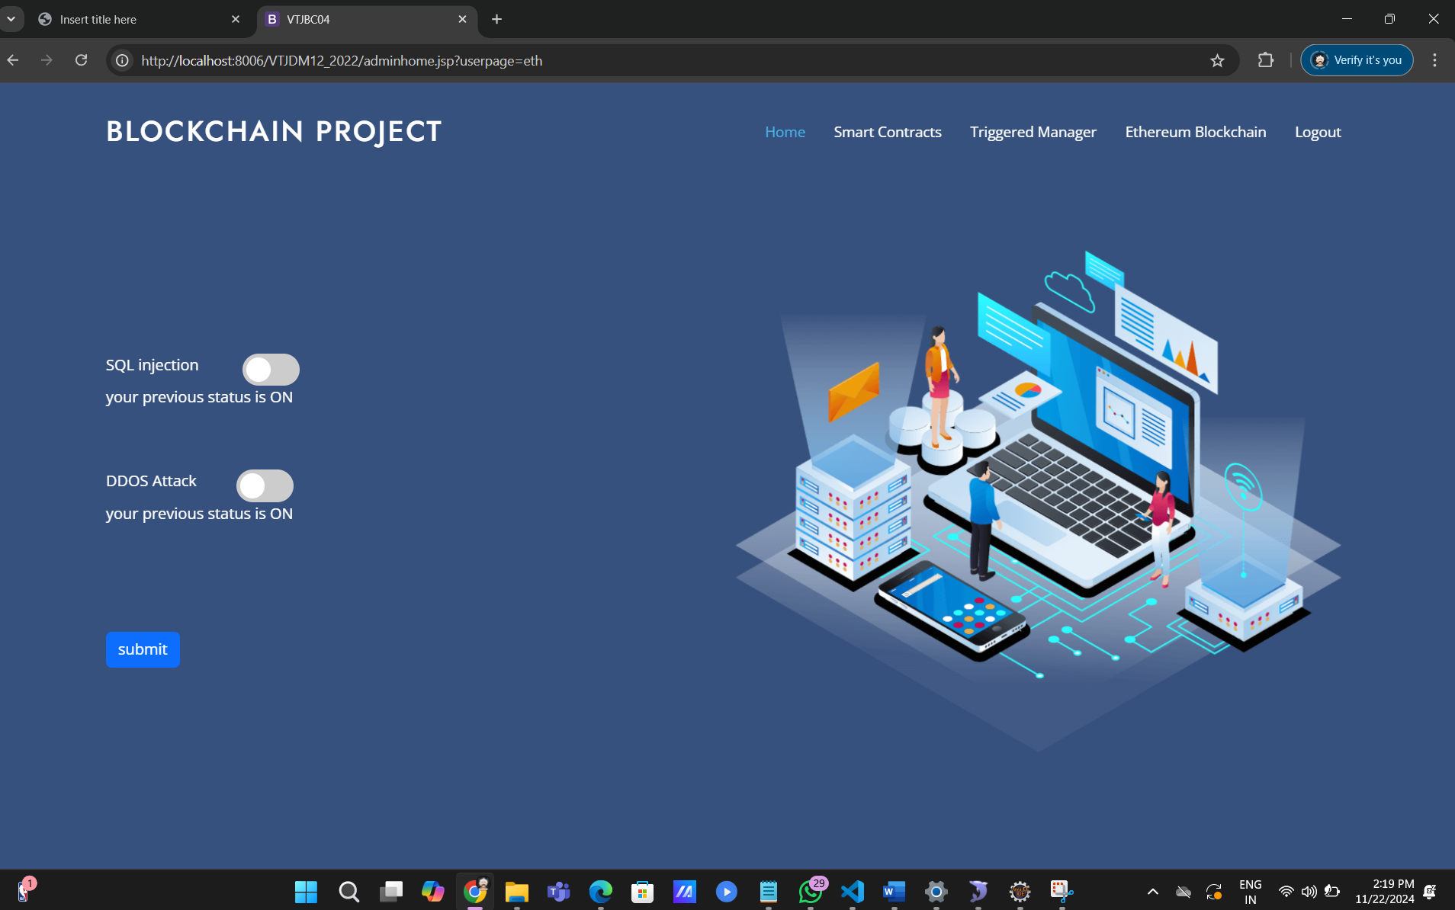
CHAPTER 8
SOFTWARE TESTING

8.1 GENERAL
The purpose of testing is to discover errors. Testing is the process of trying to discover every conceivable fault or weakness in a work product. It provides a way to check the functionality of components, sub-assemblies, assemblies and/or a finished product it is the process of exercising software with the intent of ensuring that the Software system meets its requirements and user expectations and does not fail in an unacceptable manner. There are various types of test. Each test type addresses a specific testing requirement.

8.2 DEVELOPING METHODOLOGIES
The test process is initiated by developing a comprehensive plan to test the general functionality and special features on a variety of platform combinations. Strict quality control procedures are used. The process verifies that the application meets the requirements specified in the system requirements document and is bug free.
8.3TYPES OF TESTS
Sl. No | Test scenario | User action | Expected result | Actual Result | Remarks
1. | Registration | Users registering into the system. | Register into the system. | Successfully alert registered message. | Pass
2. | Login | 1. Entered correct password. | 1. Log into the system.  2. Alert generated. | 1. Successfully logged in.  2. Successfully generated the alert. | Pass
3. | Data User | Search File, Gets the requests from owner | Massages sending data user alert is generated. | Successfully generated the alert and massages sending | Successful
4. | Data Owner | Upload a Files and send request for user | Data owner has to actions | Successfully generated the alert to data owner message | Successful
5. | Cloud Server | Data owner information, data user information,files,keys and attack details | Massages Alert is generated | Successfully generated the alert for cloud server massages | Successful

8.3.1 UNIT TESTING
Unit testing involves the design of test cases that validate that the internal program logic is functioning properly, and that program input produce valid outputs. All decision branches and internal code flow should be validated. It is the testing of individual software units of the application .it is done after the completion of an individual unit before integration. This is a structural testing, that relies on knowledge of its construction and is invasive. Unit tests perform basic tests at component level and test a specific business process, application, and/or system configuration. Unit tests ensure that each unique path of a business process performs accurately to the documented specifications and contains clearly defined inputs and expected results.

8.3.2 FUNCTIONAL TEST
Functional tests provide systematic demonstrations that functions tested are available as specified by the business and technical requirements, system documentation, and user manuals.
Functional testing is centered on the following items:
Valid Input : identified classes of valid input must be accepted.
Invalid Input : identified classes of invalid input must be rejected.
Functions : identified functions must be exercised.
Output : identified classes of application outputs must be exercised.
Systems/Procedures: interfacing systems or procedures must be invoked.
8.3.3 SYSTEM TEST
System testing ensures that the entire integrated software system meets requirements. It tests a configuration to ensure known and predictable results. An example of system testing is the configuration oriented system integration test. System testing is based on process descriptions and flows, emphasizing pre-driven process links and integration points.

8.3.4 PERFORMANCE TEST
The Performance test ensures that the output be produced within the time limits, and the time taken by the system for compiling, giving response to the users and request being send to the system for to retrieve the results.

8.3.5 INTEGRATION TESTING
- Software integration testing is the incremental integration testing of two or more integrated software components on a single platform to produce failures caused by interface defects.
- The task of the integration test is to check that components or software applications, e.g. components in a software system or – one step up – software applications at the company level – interact without error.

8.3.6 ACCEPTANCE TESTING
- User Acceptance Testing is a critical phase of any project and requires significant participation by the end user. It also ensures that the system meets the functional requirements.

ACCEPTANCE TESTING FOR DATA SYNCHRONIZATION:
- The Acknowledgements will be received by the Sender Node after the Packets are received by the Destination Node
- The Route add operation is done only when there is a Route request in need
- The Status of Nodes information is done automatically in the Cache Updating process

8.2.7 BUILD THE TEST PLAN

- Any project can be divided into units that can be further performed for detailed processing. Then a testing strategy for each of this unit is carried out. Unit testing helps to identity the possible bugs in the individual component, so the component that has bugs can be identified and can be rectified from errors.

CHAPTER 9
9.1 CONCLUSION
The spectrum of contemporary DDoS firefighting practices spans from declaring defeat and blackholing victims’ addresses via BGP in order to reduce disruptions to other parts of the data center infrastructure, to filtering in end hosts before packets enter the network stack, which is where much of the current XDP-based development is taking place. We introduced a filtering data path specialized for forwarding speed and fast LPM: on a consumer-grade 8-core machine, we have demonstrated forwarding traffic at rates exceeding 60 Mpps (i.e., 40 Gbps line rate with 64-byte packets) while subjecting all packets to a series of LPM queries in databases, each encompassing several hundred thousand network prefixes or host addresses.
9.2 FUTURE ENHANCEMENT
In the future, Our experimental evaluation has shown that the choice of LPM scheme makes or breaks the performance of such a filtering data path, and that some popular LPM schemes may be ill-suited for blacklisting applications with large address datasets due to their inherent structural limitations (insufficient memory for next hop labelling or for more specific prefixes, resulting in inability to load larger datasets). We have shown that even ostensibly minor and simple tweaks to LPM data structures and lookup algorithms may yield real-world throughput gains approaching 10 Mpps, i.e., nearly 20% of the total forwarding capacity of our test system.
9.3 REFERENCES
[1] S. T. Zargar, J. Joshi, and D. Tipper, ‘‘A survey of defense mechanisms against distributed denial of service (DDoS) flooding attacks,’’ IEEE Commun. Surveys Tuts., vol. 15, no. 4, pp. 2046–2069, 4th Quart., 2013.
[2] N. McKeown, T. Anderson, H. Balakrishnan, G. Parulkar, L. Peterson, J. Rexford, S. Shenker, and J. Turner, ‘‘OpenFlow: Enabling innovation in campus networks,’’ ACM SIGCOMM Compute. Commun. Rev., vol. 38, no. 2, pp. 69–74, 2008.
[3] L. Molnár, G. Pongrácz, G. Enyedi, Z. L. Kis, L. Csikor, F. Juhász, A. Kőrösi, and G. Rétvári, ‘‘Data plane specialization for high-performance OpenFlow software switching,’’ in Proc. ACM SIGCOMM, Aug. 2016, pp. 539–552.
[4] Intel Data Plane Development Kit (Intel DPDK). Accessed: Dec. 29, 2021. [Online]. Available: http://dpdk.org/doc/guides/prog_guide
[5] L. Rizzo, ‘‘Revisiting network I/O APIs: The net map framework,’’ Commun. ACM, vol. 55, no. 3, pp. 45–51, 2012.
[6] S. Miano, M. Bertrone, F. Risso, M. Tumolo, and M. V. Bernal, ‘‘Creating complex network services with eBPF: Experience and lessons learned,’’ in Proc. IEEE Int. Conf. High Perform. Switching Routing (HPSR), Jun. 2018, pp. 1–8.
[7] T. Høiland-Jørgensen, J. D. Brouer, D. Borkmann, J. Fastabend, T. Herbert, D. Ahern, and D. Miller, ‘‘The eXpress data path: Fast programmable packet processing in the operating system kernel,’’ in Proc. ACM Int. Conf. Emerg. Netw. Exp. Tech. (CoNEXT), 2018, pp. 54–66.
[8] A. Begel, S. McCanne, and S. L. Graham, ‘‘BPF+: Exploiting global dataflow optimization in a generalized packet filter architecture,’’ in Proc. ACM SIGCOMM, 1999, pp. 123–134.
[9] P. Gupta, S. Lin, and N. McKeown, ‘‘Routing lookups in hardware at memory access speeds,’’ in Proc. IEEE INFOCOM, Mar./Apr. 1998, pp. 1240–1247.
[10] Y. Ohara and Y. Yamagishi, ‘‘Kamuee Zero: The design and implementation of route table for high-performance software router,’’ in Proc. Internet Conf., 2016, pp. 1–10.
[11] H. Asai and Y. Ohara, ‘‘Poptrie: A compressed trie with population count for fast and scalable software IP routing table lookup,’’ ACM SIGCOMM Comput. Commun. Rev., vol. 45, no. 4, pp. 57–70, Aug. 2015.
[12] M. Antonakakis et al., ‘‘Understanding the Mirai botnet,’’ in Proc. 26th USENIX Sec. Symp., 2017, pp. 1093–1110.
[13] I. Marinos, R. N. M. Watson, and M. Handley, ‘‘Network stack specialization for performance,’’ ACM SIGCOMM Comput. Commun. Rev., vol. 44, no. 4, pp. 175–186, Feb. 2015.
[14] T. Yang, G. Xie, A. X. Liu, Q. Fu, Y. Li, X. Li, and L. Mathy, ‘‘Constant IP lookup with FIB explosion,’’ IEEE/ACM Trans. Netw., vol. 26, no. 4, pp. 1821–1836, Aug. 2018.
[15] M. Zec, L. Rizzo, and M. Mikuc, ‘‘DXR: Towards a billion routing lookups per second in software,’’ ACM SIGCOMM Comput. Commun. Rev., vol. 42, no. 5, pp. 29–36, Sep. 2012.
[16] M. Zec and M. Mikuc, ‘‘Pushing the envelope: Beyond two billion IP routing lookups per second on commodity CPUs,’’ in Proc. 25th Int. Conf. Softw., Telecommun. Comput. Netw. (SoftCOM), Sep. 2017, pp. 1–6.
[17] G. Rétvári, J. Tapolcai, A. Kőrösi, A. Majdán, and Z. Heszberger, ‘‘Compressing IP forwarding tables: Towards entropy bounds and beyond,’’ IEEE/ACM Trans. Netw., vol. 24, no. 1, pp. 149–162, Feb. 2016.
[18] M. Zec, ‘‘Improving performance in software internet routers through compact lookup structures and efficient data paths,’’ Ph.D. dissertation, Fac. Electr. Eng. Comput., Univ. Zagreb, Zagreb, Croatia, 2019.
[19] K. Sklower, ‘‘A tree-based packet routing table for Berkeley UNIX,’’ in Proc. USENIX Winter Conf., 1991, pp. 93–104.
[20] V. Giotsas, G. Smaragdakis, C. Dietzel, P. Richter, A. Feldmann, and A. Berger, ‘‘Inferring BGP blackholing activity in the internet,’’ in Proc. Internet Meas. Conf. (IMC), Nov. 2017, pp. 1–14.
[21] H. T. Kung and P. L. Lehman, ‘‘Concurrent manipulation of binary search trees,’’ ACM Trans. Database Syst., vol. 5, no. 3, pp. 354–382, Sep. 1980.
[22] P. E. McKenney, ‘‘Exploiting deferred destruction: An analysis of readcopy-update techniques in operating system kernels,’’ Ph.D. dissertation, OGI School Sci. Eng., Oregon Health Sci. Univ., Portland, OR, USA, 2004.
[23] R. Neugebauer, G. Antichi, J. F. Zazo, Y. Audzevich, S. López-Buedo, and A. W. Moore, ‘‘Understanding PCIe performance for end host networking,’’ in Proc. Conf. ACM Special Interest Group Data Commun., Aug. 2018, pp. 327–341.

